Glens of Foudland Wind Farm Community Trust

APPLICATION FOR A TRUST GRANT

The following notes describe the purpose and process of the Trust Grant system.

The expectation is that grants will be awarded up to a maximum value of £3,000.

The aim of the Trust is to support projects that fall into the category of providing a community benefit. In practice this might mean any project related to environmental issues, our community halls & schools or that supports youth activities. Other novel and imaginative projects will also be considered.

The Trust will certainly consider all such possibilities and any organisation including clubs, schools, parent groups and community based or other similar organisations may apply for a Trust grant. If in doubt, then please ask the Trust for further information or guidance.

Priority will be given by the Trust to projects where more appropriate funding sources might not be available. The Trust will consider co-funding projects, particularly where acting as a co-funder may enable the release of other larger funding from elsewhere.

The Trust is unable to fund feasibility studies or other pre-funding works where commercial companies are involved.

The fund has been set up to support projects even if they are due to run over more than one financial year. This means that projects do not have to start and finish in any one financial year. However, the trust may be unable to commit all the finds necessary to a project if they fall into this category as this may impact their ability to offer funding for new projects as they apply.

Applications for funding are welcomed from community groups within the area of benefit as shown in the map below. A copy of the plan can also be found at https://glens.org.uk/media/2637860/glensoffoudlandwfctarea.pdf.

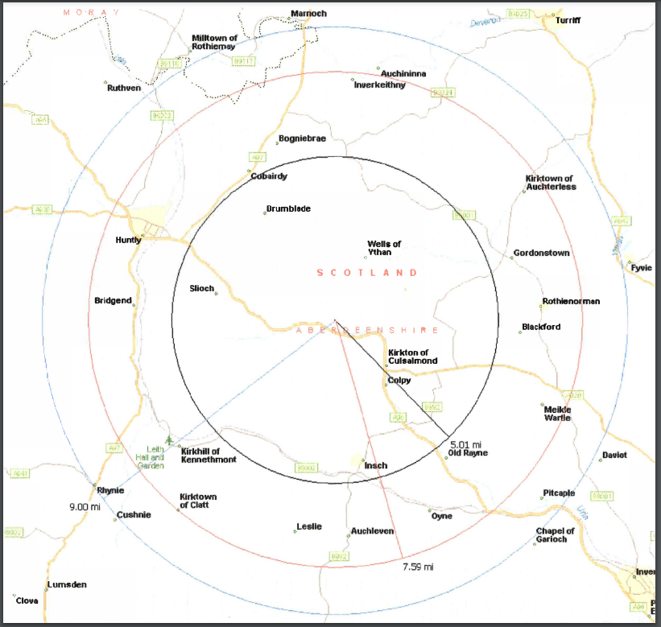

The Trust has been set up as an independent body and will therefore make all its own decisions with regard to funding requests. In the event that expert advice is needed to come to a decision, it will consult with suitable parties to help with that process.

The Application Form below should be completed in full and sent electronically to windfarmtrust@gmail.com

The Application Form is also available from the following Community Councils – Strathbogie, Bennachie, Tap o-Noth as well as Aberdeenshire Council.

Glens of Foudland Wind Farm Community Trust

FUNDING APPLICATION FORM

Please read the finding application notes before filling in this form- use additional paper if necessary.

- Name of applicant and contact details.

- What is the status of the organisation you are requesting funds for (tick all that apply).

Limited Company ☐ Commercial Business ☐ Registered Charity ☐
Community Organisation/Club ☐ Voluntary Organisation ☐ Individual ☐
Other (please specify in the box below) ☐

- Describe your project.

A clear description of your project, why it is important and who it will benefit.

- Costs

4.1 How much will your project cost? Please provide supporting quotations

  - Amount of funding sought from the Glens of Foudland Windfarm Community Trust

  - Other sources of funding applied for or secured

- Timescale

When do you want to start your project and how long will it take?

- Successful Grants

Who should a cheque be made payable to should your application be successful?

Please supply an address where a cheque should be sent?

Applicant Signature | Print name | Date
Application Number  (For Trust Use only) | Date discussed  (For Trust Use only) | Decision  (For Trust Use only)

